Zumbro Bottoms Back County Horsemen of Minnesota Membership Form
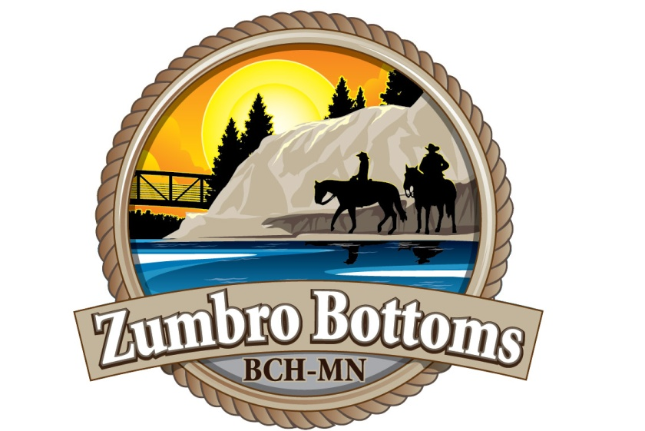
Zumbro Bottoms, located in SE Minnesota, is a special place. This group is about enhancing your
equine riding and camping experience at the Zumbro Bottoms Unit of the Richard J Dorer State Forest
and protecting this treasure for future generations of equine riders.

Check out our website at - http://zumbrobottomsbchmn.weebly.com
Email: zumbrobottomsequestrians@gmail.com or Bruce Kvittem 507-259-6127

Please join today!!
Annual dues are $25.00 individual or $30.00 per family. Annual dues begin January of each year.

ZB Back Country Horsemen - MN Membership/Renewal

Name(s)___________________________________________________________________________________

Address___________________________________________________________________________________

City_____________________________________ State_________ Zip___________

Email Address______________________________________________________________________________

Phone Number _____________________________________________________________________________

I am interested in helping - NO - YES - I can_______________________________________________________

Membership (Please circle) Individual $25.00 Family $30.00 Supporting $10
Additional donation $______________ Primary Chapter Name_________________
Total enclosed $__________________

Make Checks Payable to: ZB BCH MN
Mail to:
Angie Murphy
19631 - 596th Street
Kellogg, MN 55945

